High Level Design

Blockchain Enabled Supply Chain Tracker for E-commerce

Revision Number: 1

Last date of Revision: 28/11/2021

|  |  |
| --- | --- |
| Team Members | |
| Abhi Mishra | B2020002 |
| Abhishek Anand | B2020003 |
| Aditya Krishnan | B2020005 |
| Diksha Davar | B2020015 |
| Rishabh Pareek | B2020040 |
| Dhruv Ukawala | B2020060 |

Abstract 3

**1 Introduction** 4

1.1 Why this High-Level Document (HLD)? 4

1.2 Scope 4

**2 General Description** 5

2.1 Product Perspective 5

2.2 Problem Statement 5

2.3 Proposed Solution 5

2.4 Further Improvements 5

2.5 Technical Requirements 5

2.6 Data Requirements 6

2.7 Tools Used 6

2.7.1 Hardware Requirements 6

2.8 Constraints 6

2.9 Assumptions 7

**3 Design Details** 7

3.1 Traditional Methodology 7

Advantages 7

Disadvantages 7

3.2 Blockchain enabled E-commerce process 7

Advantages 7

Disadvantage 8

3.3 Event Log 8

3.4 Error Handling 9

**4 Performance** 9

4.1 Application Compatibility 9

4.2 Scalability 9

5 Conclusion 9

# Abstract

Blockchains are receiving interest from stakeholders in a variety of industries, including logistics and supply chain management. Blockchain technology can help to record every single asset as it moves through the supply chain, manage orders, receipts, and payments, and track digital assets like warranties and licenses in a centralized and transparent manner. The technique used in the article gives a detailed analysis of how blockchain fits within the supply chain business. It describes the influence that blockchains will have on the supply chain business, including scalability, performance, consensus method, privacy issues, location evidence, and cost, as well as the impact that blockchains will have on the supply chain industry.

It describes the influence that blockchains will have on the supply chain business, including scalability, performance, consensus method, privacy issues, location evidence, and cost, as well as the impact that blockchains will have on the supply chain industry. It begins by discussing the tradeoff between consensus cost, throughput, and validation time, then moves on to a suggested high-level architectural approach, and closes with a discussion of the adjustments required and obstacles faced for in-vivo blockchain deployment in the supply chain industry. While the technological features of modern blockchains can effectively facilitate supply chain use cases, the numerous challenges that remain place a large number of changes and additional research efforts in front of us in order to achieve a global, production-level blockchain for the supply chain industry.

# 1 Introduction

## 1.1 Why this High-Level Document (HLD)?

The high-level design will act as the architecture for building blockchain model. It will contain necessary steps which will acts as user guidance while developing application. This document will also include problem we might be facing while developing blockchain application.

The HLD will cover the following aspects:

* System Architecture
* Brief description of system
* Technical Requirements
* Flow Diagrams

## 1.2 Scope

The HLD document covers the problem statement, proposed solution, data definition, technical requirements, tools, constraints, process flows, error handling, performance, reusability and so on. Being a High-Level Document, the concepts are explained in such a way it will also be understandable by the business people.

# 2 General Description

## 2.1 Product Perspective

## Blockchain technology can effectively contribute in recording every single asset throughout its flow on the supply chain, contribute in tracking orders, receipts, and payments, while track digital assets such as warranties and licenses in a unified and transparent way.

## 2.2 Problem Statement

* Record product data from origin to end user’s delivery in supply chain
* To update the blockchain with the transaction detail at each point of sells
* Crosscheck the product detail with point of origin transaction with the point of sells transaction to check its originality

## 2.3 Proposed Solution

There can be multiple benefit of using blockchain in supply chain. Specially for ecommerce. By recording the product detail throughout the product life cycle across the supply chain nodes increase the transparency and the trust of the stack holders of the supply chain. Customer usually faces the problem of getting duplicate items when it buys through the e-commerce platform. To solve this issue blockchain will record every transaction detail from the origin of product and it will compare and trace the product until it reaches to the end users. So if someone will try to infuse the fake product detail at any nodes in supply chain it will not accept since fake data won’t be available in blockchain and customer will also able to validate it whether it is original or not.

## 2.4 Further Improvements

We can further allow trusted third party that can allow greater scalability, as any number of participants can virtually participate in the chain with appropriate trust level, and increased innovation by

deploying the dynamics of blockchains as enablers of instant payments (through cryptocurrency),

smart contracts, and low transaction fees without having the cost overheads of third parties. Last, but

not least, a shared, immutable ledger with codified rules can potentially eliminate the audits required

by internal systems and processes.

## 2.5 Technical Requirements

To track each product there should be single RFID code for each node. Since there will be maximum of 3-4 nodes in E-commerce supply chain we will be needed RFID code scanner.

To use blockchain at large scale it will also require high power computing machines with storage infrastructure.

We will also using SHA-256 to encrypt blocks.

## 2.6 Data Requirements

The data stored in the blocks are the transaction details and product information such as:

* Company name
* Place of Product origin
* MRP
* Product Segment
* Product Description
* Product cost price at each node
* Buyer’s and seller’s identification number or name
* Date of Transactions
* Expiry date if required

## 2.7 Tools Used

Python programming language is used for development along with the libraries such as Hashlib, JSON. The Flask framework is used for API. GitHub is used as a version control platform.

 



*Figure2: Logos of tools used*

* PyCharm and Spyder is used as the IDE
* GitHub is used as the version control platform

### 2.7.1 Hardware Requirements

High computing powered computers are the main requirement for the mining process of the blocks.

## 2.8 Constraints

The implementation of the Peer-to-Peer networking will be challenging as the application is developed in silos in individual systems.

## 2.9 Assumptions

In order for blockchain technology to be implemented for Supply chain, the manufacturer, distributer and sellers should agree om common ground share the transaction detail. Buyers should be able to validate the product for its originality. This is a major assumption in implementing this solution.

# 3 Design Details

## 3.1 Traditional Methodology

#### The old strategy works by allowing each company to operate independently. Furthermore, each organisation has its own set of rules, regulations, and processes, with no commonality. This makes it difficult for E-commerce businesses to complete their tasks.

#### Advantages

* Company can maintain their own private records of their customer’s transactions
* The Company can devise their own frameworks and processes according to their convenience

#### Disadvantages

* Customers providing fake data
* companies having incomplete data about the transactions
* Detecting legit transactions as fraud
* Increase in the processing time
* Fraud in delivering the wrong and duplicate product

## 3.2 Blockchain enabled E-commerce process

In this proposed solution, a set of E-commerce enterprises, an external agency, and a central authority will all be connected in this proposed approach. Each member serves as a node in the network. The customer gives the information to the company of her/his choice. Regarding the given documents, that company will conduct a background check in collaboration with an external agency. The client documentation are then validated by the Company, the external agency, and the central authority. The authority changes the details to a block in the network after collecting a particular amount of customer records, and then broadcasts this information to all nodes in the network. If a consumer approaches another firm for services, that company can request access to the customer's information from the database.

The Company can cross-verify the identification after access is allowed. If there is a change in the details, it will be highlighted and the necessary verification will be carried out. The blockchain is updated once the verification has been confirmed.

#### Advantages

* Data collection, modification and revision is made easy
* Increased efficiency in operations
* Better standardization
* Accurate information
* Decrease in the processing time
* Avoid fraud and fake identity
* Improved customer experience

#### Disadvantage

* The E-commerce Companies have to give up some of the customer’s data which was previously private to their own
* There will be a standardization in the process which may force some Companies to change their processes

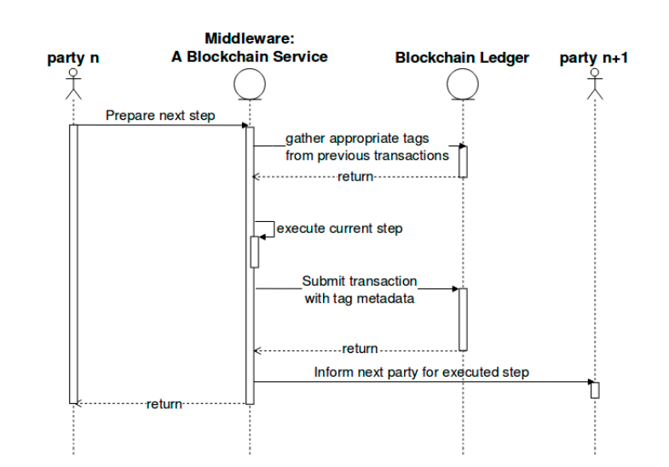

*Figure 4:Proposed Framework*

## 3.3 Event Log

Event logging takes place at each step right from the customer and distributor’s details are loaded to the database. The events are logged at the following steps:

* The details uploaded to the database
* Verification completion
* Uploading of the data to the blockchain
* Broadcasting the information
* Validation by the external agency and the central authority
* Access granted by the Central Authority

## 3.4 Error Handling

When there is any error during the process, an appropriate message is displayed as to at which step the error occurred.

# 4 Performance

## 4.1 Application Compatibility

## Only high-performance computing platforms will be compatible with the created solution. Because mining a block consumes a lot of resources and is costly.

## 4.2 Scalability

## The application may be scaled to a large number of users. If any of the financial institutions wants to join the consortium, they must be added as a node to the current network and given the necessary permissions.

## 5 Conclusion

Finally, the proposed solution of using blockchain technology to carry out the verification processes will give participating E-commerce companies an advantage over non-participants in terms of product information authenticity and dependability, operational efficiency, and improved customer experience. This also aids central governing authorities in better and more efficient customer monitoring by minimizing the quantity of fraud and duplicate item sales, among other things. This can be accomplished if the participating E-commerce enterprises can standardize their operations and relax their data policies, assuring client data protection.